1. Teacher G does NOT wait for the end of the term to find out how much the students learn. With which does teacher G agree?
- Formative evaluation
- Authentic evaluation
- Summative evaluation
- norm-reference evaluation

2. Even in the process of teaching, Teacher J finds out if her students understand what she is teaching. What is teacher J engaged in?
- Summative evaluation
- Criterion-reference evaluation
- Norm-referenced
- Formative

3. To what extent were the objectives of
the course met? This is the concern
Of the process of ________evaluation
- Authentic
- Criterion-referenced
- Norm-referenced
- formative

4. Other than finding out how well the course objectives were met, Teacher K also wants to know his student’s performance when compared with other students in the class. What is Teacher K interested to do?
- Authentic evaluation
- Formative evaluation
- Criterion-referenced evaluation
- Norm-referenced evaluation

5. Which is a valid assessment tool if you want to find out how well your student can speak extemporaneously.
- Performance test in extemporaneous speaking
- Written quiz on how to deliver extemporaneous speech
- Display of speeches delivered
- Writing speeches
6. Which must go with self-assessment for it to be effective?
- External monitor
- Consensus of evaluation results from teacher and student
- Scoring rubric
- Public display of result of self-evaluation

7. Which must be present for self-evaluation to succeed?
- Consensus between teacher and student regarding evaluation result
b. Teacher’s approval of self-evaluation result
c. Teacher’s monitoring of self-evaluation process
d. Student’s intrinsic motivation to learn

8. After a lesson on the atom, the students were asked to work on a physical model of the atom to determine learning. What MI I being enhanced?

- Linguistic
- Interpersonal
- Mathematical
- Kinesthetical

9. Teachers are encouraged to make use of authentic assessment. Which goes with authentic assessment?
- Unrealistic performances
- De-contextualized drills
- Real world application of lesson learned
- Answering high multiple choice test items

10. Which will be the most authentic assessment tool for an instructional objectives on working with and relating to people?
- Conducting mock election
- Home visitation
- Organizing a community project
- Writing articles on working and relating to people

11. Which is the most reliable tool of seeing the development in your pupil’s ability to write?
- Portfolio assessment
- Scoring rubric
- Interview of pupils
- Self-assessment

12. How much of the scientific method has your pupils acquired? This is best measured in their skill to_______
- Generic and test hypotheses
- Critic and evaluate
- See connectedness of events
- II and III
- I and II
- I only
d. I, II and III

13. Here is a test item ____ is an example of a mammal. What is defective with
this test item?
- beginning of the sentence
- It is a very short question
- It is an insignificant test item
- It is very elementary

14. Which improvement’s should be done this completion test item. An example of a mammal is______
- The question should have only one acceptable answer
- The blank should be at the beginning of the sentence
- The item should give more cues
- The blank should be longer to accommodate all possible answer

Study this test and answer question # 15-21
Teacher Z gave this test to her pupils. Study it thoroughly then answer the
Question that follow.

___1. sum a. number to be added
___2. addends b.25
___3. the formula for
the area of a rectangle c. the answer in
addition
___4. multiplier d. Alexander Venn
___5. product e. A=1 x w
___6. formula for the
perimeter of a rectangle f. 3/2
___7. he introduced
the Venn diagram g. P=2(1)+ 2(w)
____8. an example of an
improper fraction h. the number by which you multiply
___9. equivalent of ¼
in decimal i. the answer in
multiplication
15. Are the items in the correct columns?
- No, because this is a perfect matching type of test
- Yes, that is exactly is a perfect matching type of test
- Yes and no, that depends on teacher’s lesson objective.
- No, the items on the right should be on the left, the items on the left should be on the right

16. One defect of teacher Z’s test is the items to match are_____
- Very few
- Homogenous
- Heterogeneous
- insignificant

17. How can the test be improved?
- Ask more significant items
- Add to the number of foils
- Increase the number of items to match
- Increase the difficulty level of the test

18. Which can be a basic improvement of the test
- Increase the facility index of the test
- Make the items heterogeneous
- Increase the number of test items
- Make the items homogenous

19. Which does the test lack?

- Directions
- Label of the columns
- Foil among the options
- One correct answer

- I, II, and III
- III only
- I, III, IV
- II and III

20. Which statement is true of the test?
- It is a reliable test because it covers a wide scope of subject matter
- It is an ideal perfect matching type of test
- It is a good type of an imperfect matching test
- The items can be answered by mere process of elimination

21. Which principle in test construction for a matching type of test was not observed?
A. If your matching test is of the imperfect type, caution the examinee.
B. Test items must be heterogeneous
C. Test items must be homogenous
D. If your matching test is of the perfect type, inform then examinee.

Here is a test. Study it thoroughly then answer the question # 22-29

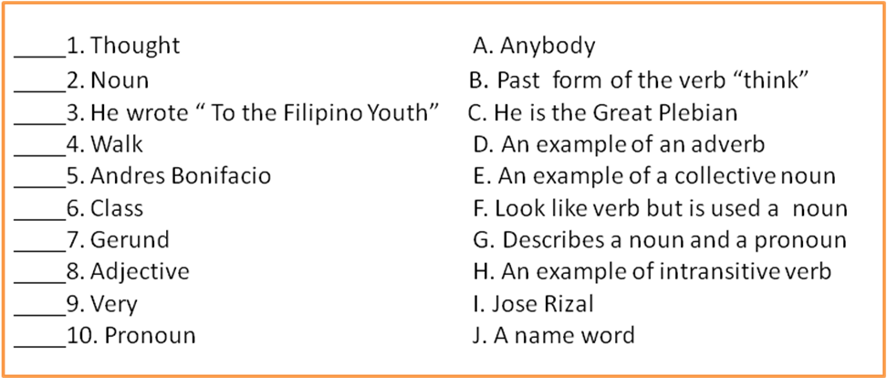
22. What’s faulty with the test?
A. The options have no joker.
B. The test items are on trivia.
C. Some items are n meant to be asked in a matching type of test.
D. The test items are limited in number.

23. Which is one way to improve the test?
- Reduce the difficulty index.
- Increase the options by at least two.
- Add to the number of items.
- Make it a perfect type of matching test.

24. What’s wrong with the test items? The items are_________.
- Heterogeneous
- Homogeneous
- Easy
- Insignificant

25. How can you improve the test?
- Make the items heterogeneous.
- Make the items homogeneous
- Reduce the facility index
- Widen its scope and coverage.

26. What does the test lack?
- 5 additional test items
- More names of persons
- Blank before the capital letters
- Distracters/s

27. Which is TRUE of the test?
- The test items are homogeneous.
- The test is quite short for a matching type
- The right and the left columns should exchange position
- There are enough foils in the options.

28. Which is TRUE of the test?
- Some items can be answered by mere process of elimination.
- It is classified as an imperfect matching type of test.
- It is reliable because it has a wide coverage of subject.
- We have more than enough foils in the options

29. Which does the test lack?
- Additional test items
- Colum labels
- Directions
- I and III
- II and III
c. I and II
d. I, II, and III

30. What’s defective with this test item?
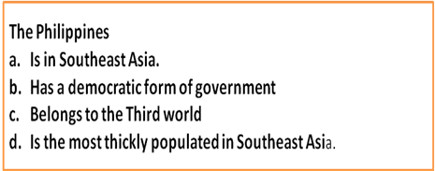
- The stem does not contain the question.
- The stem is very short.
- It has several correct answers.
- I only
- II only
c. III
d. I and III
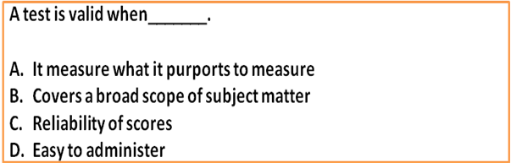
31. How can you improve on this multiple choice test item?

- Construction the options in such a way that the grammar of the sentence remains correct.
- Make the length of the options uniform.
- Make the options parallel.
- Pack the question in the stem.

32. Read this True-False test item and answer the question that follows:

Andres Bonifacio founded the Katipunan. Which principle in test construction is violated?
a. Test something significant.
b. Make use of simple words
c. There should be sufficient reason to make the statement false.
d. Avoid qualitative terms

33. Here is teacher D’s lesson objective: “To trace the causes of Alzheimer’s disease”. Which is a valid test for this particular objective?

- Do young people also get attacked by alzheimer’s disease? Support your answer.
- What is an alzheimer’s disease ?
- Can an alzheimer’s disease be traced to old age? Explain your answer.
- To what factors can Alzheimer’s disease be traced? Explain.

34. Here is Teacher E’s instructional objective: “To distinguish between proper and improper fraction. “ Which is a valid test item for such objective?

a. Define proper and improper fractions and
b. Put a check (/) on the proper fractions and an X over the improper :1/2, 4/3,3/4,5/6,8/7,9/7,2/10,6/12.
c. Is an improper fraction really a fraction. Explain your answer.
d. Can you add proper and improper fractions together? Explain
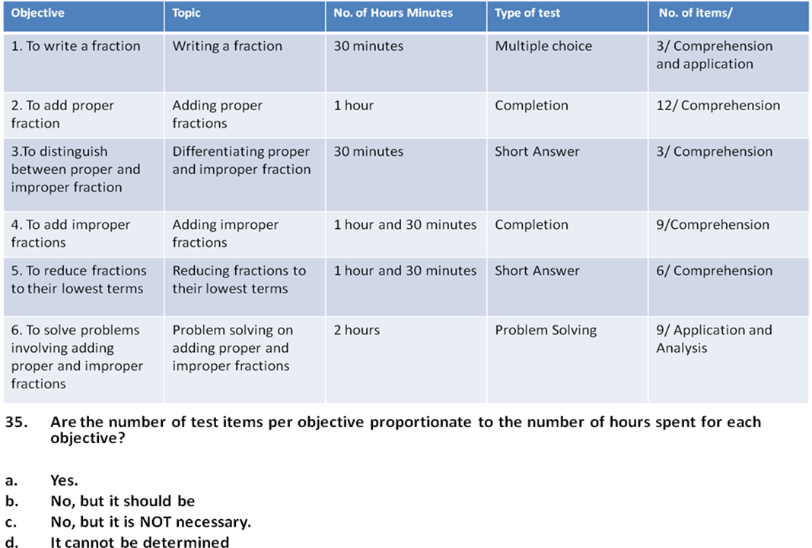

35. Are the number of test items per objective proportionate to the number of hours spent for each objective?
a. Yes.
b. No, but it should be.
c. No, but it is NOT necessary.
d. It cannot be determined.

36. Is this test item valid for objective #3 in the Table of Specifications?

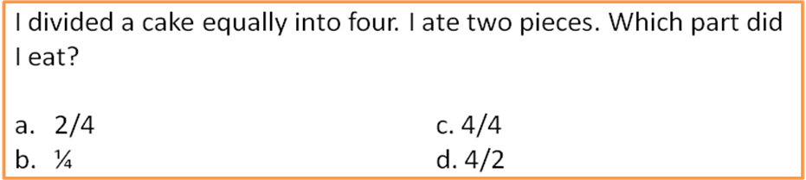

- Yes
- No
c. Yes, but needs to be improved
d. No, because it is insufficient

37. Which test item is in accordance with objective #3 in the Table of Specifications?
- What is the difference between proper and improper fractions?
- Give n example of an improper fraction
- Given an example of a proper fraction
- Define proper and improper fraction.

38. If you should be true to your Table of Specification, when you make your test, on which objectives should you have the least items?
- Objective #2
- Objective #1
- Objective #3
- Objective #1 and #3

39. If you should be true to your Table of Specification, when you make your test, on which objectives should you have the least items?
- Objective #5
- Objective #1
- Objective #4
- Objective #1 and #6

40. Which is valid test item for objective #5?
- How do you reduce a fraction to its lowest term?
- Is 4/6 equal to 1/3?
- What is meant by “lowest term”?
- What is 3/6 in its lowest term?

41. Which is restricted essay test?

a. What should the Department of Education do to solve the perennial problem of poor quality of basic education? Give and justify your proposals.
b. If you were President of the Philippines, what would you do to spur the nation’s economic growth?
c. What conditions must be present for photosynthesis to take place? Explain each factor in not more than 3 sentences.
d. Why are more and more people sick of Alzheimers disease.

42. Choose an appropriate curriculum especially that the child’s mind does not contain any innate ideas was an advice from ____.

- Plato
- John Locke
- Rousseau
- B.F. Skinner

43. Who claimed that children are natural learners and therefore, must be taught in natural settings?
- Piaget
- Froebel
- Montessori
- Kohlberg

44. According to Wiggins and McTighe, one facet of understanding, an evidence of learning, is empathy. Which test questions assesses capacity to emphatize?

- State the Pythagorean theorem.
- Test on Romeo and Juliet. Imagine you are Juliet. Write your thoughts and feelings why you have to take this desperate action?
- Diagnose and fix the broken lamp.
- Translate all the words in Spanish and give the meaning of the sentence.

45. The best way to assess learning is to use real-life situations, objects and materials existing in the environment. Hence, teachers are encouraged to use ______.

- Rating scale
- Pencil- and-paper test
- Observation technique
- Authentic assessment

46. The main purpose in administering
a pre-test and a post test to students is
to ____.

- accustom the students in frequent testing
- keep adequate records
- measure the value of the material used
- measure gains in learning

47. A sentence that comes before is missing. How is understanding of a concept shown by learners?

I. By using and adopting it
II. By repeating what has been heard
III. By memorizing what has been read
- II
- III
- II and III
- I

48. Understanding of a concept is revealed
as _____, the ability to accomplish tasks successfully under pressure.

- Performance in teamwork
- Performance know-how
- Performance in arts
- Performance at works

49. The more information teachers obtain about how students perform, the more capacity they have to rethink their pedagogy, and the more opportunities they create for students success. Which statement BEST explains the text above.

- Teachers should keep track of learning outcomes.
- Teachers should keep records of family background.
- Teachers should file information.
- Teachers should teach to test.

50. The collegial process of developing and evaluating performance assessments help teachers to understand the ___ needed to produce high quality performance.

- test
- information
- materials
- scaffolding

51. During the sensorimotor period, a child does not see things in abstract form. Which of the following should teachers remember in teaching and assessing young children’s performance?

- Use of pictures may not be necessary.
- Use of concrete objects is not necessary.
- Printed words are easier to understand than pictures.
- Colored pictures are more effective than printed sentences.

52. Which of the following statements is/are NOT TRUE about assessment?

- Feedback is the most important factor in assessment.
- Only those that can be objectively measured should be taught.
- Assessment should follow a developmental pattern.
- Identifying systematic errors committed by students should be the basis of remedial instruction.

  - II only
  - IV only
  - III and IV
  - I and II

53. Referring to assessment, what are the essential features that should be explained to the learners?

- Role of learners in the assessment
- Why learners will be assessed
- How their performance will be measured.
- How the results will be used.

a. II, III, IV
b. I, II, III
c. II, III, IV
d. I, II, III, IV

54. To identify learning needs and respond to such needs the teacher administers a ____ test.

- Formative
- Summative
- Periodic
- diagnostic

55. In constructing test items the teachers considers the alignment of ____ with assessment.

- Content and process
- Monitoring and evaluation
- Instructional objectives
- Instructional materials

56. The principle of learner ____ makes assessment a shared responsibility with the teacher.

- Performance
- Accountability
- Responsibility
- evaluation

57. The Department of Education directed that the lowest passing grade is ____ % and the lowest failing grade is ___ % in the report card.
- 70-60
- 75-70
- 75-65
- 70-50
58. Among the components of the learner’s marks/ratings, Behaviour is reflected in

- Values Education (CERC)
- English
- Filipino
- Outputs/Projects

59. Test scores are totalled at the end of each grading period and computed using the formula:

a. [Students score ÷ Highest possible score] x 100
b. [Highest score ÷ lowest possible score] x 100
c. [Test score = transmutation table] x 100
d. [Students’ score x 100 %]

60. Scoring guides for rating open-ended questions are called ____.

- Outputs
- Outcomes
- Rubrics
- scales

Read the rubric for assessing outputs and answer question #61.

8-10 pts – Demonstrates imaginative thinking and unique qualities
5-7 pts – Demonstrates moderate imaginative skills
1-4 pts – Lacks imaginative thinking

61. What is being assessed by the above criteria?
  - Appeal
  - Creativity
  - Aesthetic
  - Workmanship

62. Which of the following assessment tools would you recommend if one should adhere to constructivist theory of learning?

- Constructed response test
- Performance test
- Checklist of a motor screening test
- Observation test

          - I and II
          - II and III
          - I, II and III
          - I, II and IV

63. Which of these are non-threatening means of assessing learning outcomes?

- Portfolio
- Self-evaluation
- Peer evaluation
- Learning Journals

        - I and II
        - I and III
        - I, II and IV
        - II and III

64. A criterion-referenced test is designed to determine whether or not a student has ___ .

- Performed well in a wide content coverage
- Performed higher than the other members of a group
- Reached a present target
- Reached a performance level on a specific skill

65. What is an alternative assessment tool for teaching and learning consisting of a collection of work/artifacts finished or in-progress accomplished by the targeted clientele?

- Rubric
- Achievement test
- Evaluation instrument
- Portfolio

66. Which is a scoring guide that lists the criteria and their levels of quality on which evaluation will be focused?

- Journal
- Portfolio
- Rubric
- Stem
67. Which of these approaches would reform assessment of learning outcomes?

- Use standards as means of giving feedback on student learning.
- Compare results of performance of all schools.
- Focus on testing without investing a learner’s special needs.
- Apply sanctions on low performing schools.

68. Essay questions are used in an achievement test when _______.

a. most of the material sampled is factoral information.
b. a wide sampling of material is desired
c. originality is a factor in the response
d. little time is available for construction and scoring

69. Which of the following are alternative assessments?
- Portfolio, exhibits, journals
- Paper and pencil test, demonstration, reports
- Student self-assessment, authentic assessment, surveys
- Multiple choice, structured observations, sentence completion

70. The constructivist theory of learning postulates that children learned by doing. Based on the theory, which of these would you consider in assessing learning?

- Focus is on the product
- Rubric criteria should be set
- Focus is on process
- Multiple observation

- I and II
- II and III
- III and IV
- I and IV

71. Which among the indicators could be most useful for assessing quality of schooling?

- Participation rate
- Cohort survival rate
- Net enrolment rate
- Drop-out rate

72. Which are the two (2) most important underpinning knowledge and skills for effective student assessment?

- Alternative assessment systems including formative, summative, descriptive and negotiated approaches
- Assessment principles of reliability, validity, flexibility, authenticity, sufficiency and consistency
- Characteristics of the learner
- Ethical responsibilities including confidentiality in the conduct and results of student assessment
- School policies on student assessment
- I and II
- II and III
- III and IV
- I and IV

73. You would like to assess students ability to write a portfolio. What type of test will determine their ability to organize ideas, and think critically?

- Long test
- Essay test
- Formative test
- Summative test

74. When a student clarifies information from conclusion, what cognitive domain is involved?
- Analysis
- Evaluation
- Application
- Synthesis
75. In the context of the six facets of understanding cited by Wiggins and McTighe, what is a proof of a student’s understanding a principle?

- Repeating the principle given by the teacher
- Applying it to solve his/her problem
- Stating it from memory.
- Memorizing it.

76. Which of the following statements concerning test validity and reliability is most accurate?

- A valid test is a reliable test.
- A reliable test is a valid test.
- A test can not be valid and reliable unless it is objective.
- A test can not be valid and reliable unless it is standardized.

77. The instructions for a test are made simple, clear, and concise. This is part of which of the following characteristics of a good test?

- Objectivity
- Economy
- Administrability
- Scorability

78. An entering student in college would like to determine which vocation is best suited for him. Which of the following tests is most appropriate for his purpose?

- Intelligence test
- Readiness test
- Achievement test
- Aptitude test

79. Teacher G gave a test in grammar. She found out that one half of the class scored very low. She plans to give another test to the pupils who scored very low to find out exactly where they are weak. Which type of test is this?

- Placement test
- Diagnostic Test
- Achievement Test
- Intelligence Test

80. With manner of answering as criterion, which of the following types of test does NOT belong to the group?

- Multiple choice
- True-False
- Matching
- Completion

81. With the mode of answering as point of
reference, which of the following types of
test does NOT belong to the group?
- Problem –solving
- Matching
- Completion
- Essay

82. Which of the following is precise
meaning of evaluation?

- Collecting data relevant to personal characteristics
- Administrating teacher- made tests
- interpreting and attaching value to data collected
- Scoring accomplished tests

83. Which is NOT a characteristic of authentic assessment?

- Is focused on lifelike, meaningful, relevant types of student learning
- Offers opportunities to study problem intensively
- Easy to complete
- Fruitful in terms of genuine learning

84. Which is the LEAST authentic mode of assessment?
- Paper-and-pencil test in vocabulary
- Oral performance to assess student’s spoken communication skills.
- Artistic production for music or art subject.
- Experiments in science to assess science method.
85. Which of the following may NOT be adequately assessed by a paper-and-pencil test?

- Subject-verb agreement
- Vocabulary
- Multiplication skills in Math
- Sight reading in Music

86. Teacher B wants to determine student’s strengths and weaknesses in the use of laboratory equipment. Which assessment procedure will be most appropriate and authentic?

- Observation of student’s use of laboratory equipment while they conduct experiments.
- Paper-and-pencil test that requires students to enumerate the do’s and don’ts’s in the use of laboratory equipment.
- Practicum test on the use of laboratory equipment.
- Requiring students to draw and label the laboratory equipment.

87. Marking on the normative basis means that____.

- The normal curve of distribution should be followed.
- Some students must fail.
- Fewer students must get high marks.
- Grades show how a student achieves relative to other students.

88. Teaching by objective logically goes hand in hand with which type(s) of evaluation?

- Norm-reference
- Criterion-referenced
- Standardized
- Norm-referenced and standardized

89. You were tasked to test this hypothesis. “ The more a teacher knows about a specific subject matter, the better she can teach it.” Which variable could be used as the dependent variable?

- teacher’s yearly performance evaluation rating
- Personality traits of the teacher
- Incentives offered to teachers
- Motivation from the school head

90. The difficulty index of a test item is one (1). What does this mean?

- The test item is very good, so retain it.
- The test item is difficult.
- The test item is extremely easy.
- The test item is not valid.

91. The facility index of a test item is .50. This means that the test item is_________.

- Valid
- Moderate in difficulty
- very easy
d. reliable
92. The discrimination index of a test item
is -.35. What does this mean?

- More from the upper group got the item correctly.
- More from the lower group got the item correctly.
- The test is quite reliable.
- The test item is valid

93. The discrimination index of a test item is +48. What does this mean?

- An equal number from the lower and upper group got the item correctly.
- More from the upper group got the item wrongly.
- More from the lower group got the item correctly.
- More from the upper group got the item correctly.
94. If the difficulty index of your test item
is .98, what should you do with this item?

- Revise it
- Reject it
- Retain it
- Reserve it for another group of pupils.

95. If the difficulty index of your test item
is .10, what should you do with this item?

- Retain it.
- Revise it.
- Reject it.
- Reserve it for another group of pupils.

106. How do you consider option B?

- Most effective distracter
- Effective distracter
- Ineffective distracter
- Attractive option

107. How do you consider option B?

- Most effective distracter
- Effective distracter
- Ineffective distracter
- Attractive option

108. Your percentile rank in class is 60%.what does this mean?

- You got 40% of the test items wrongly.
- You scored less than 60% of the class.
- You got 60% of the test items correctly.
- You scored better than 60% of the class.

109. Here are raw scores in a quiz: 97,95,85,83,77,75,50,10,5,2,1.To get a picture of the group’s performance, which measure of central tendency is most reliable?

- Mode
- Mean
- Median
- None. It is best to look at the individual scores.

110.Here are raw scores in a quiz: 97,95,85,83,77,75,50,10,5,2,1.Which is the median?

- 75
- 52.72
- 76
- 77

111. Here is a score distribution: 98, 93, 93, 93, 90, 88, 87, 85, 85, 85, 70, 51, 34, 34, 34, 20, 18, 15, 12, 9, 8, 6, 3, 1. Which is a characteristic of the score distribution?

- No discernable patterb
- Tri-modal
- Bi-modal
- Skewed to the right.

112. HERE IS THE SCORE DISTRIBUTION: 98,93,93,93,90,88,87,85,85,85,70,51,34,34,34,20,18,15,12,9,8,6,3,1. Which is the range?
- 93
- 85
- 97
- Between 51 and 34

113. Which measure of the central tendency is most reliable when scores are extremely high and low?

- Cannot be identified unless individual scores are given.
- Mode
- Mean
- median

114. Which is true when standard deviation is small?

- Scores are tightly bunched together
- The bell curve is relatively flat.
- Scores are spread apart.
- Scores are toward both extremes.
115. Which is true when standard deviation is big?

- The bell curve shape is steep.
- Scores are spread apart.
- Scores are concentrated
- Scores are not extreme

116. You have computed the mean and you want to get more information about the distribution scores. Which measure of variability is most appropriate?

- Standard deviation
- Mode
- Semi- interquartile range
- Range

117. You have computed the mean and you want to get more information about the distribution scores. Which measure of variability is most appropriate?

- Standard deviation
- Mode
- Semi- interquartile range
- range

118. There is a negative correlation between amount practices and number of errors in tennis. What does this mean?

- The increase in the amount of practices does not al all affect the number errors.
- decrease in the amount of practice goes with decrease in the number of errors
- As the amount of practice increases, the number of errors decreases
- The decrease in the amount of practice sometimes affect the number of errors

119. Which one indicates a strong negative correlation?
- -75
- -10
- -25
- -15

120. Complete this analogy:
Positive correlation is to direct relation as Negative correlation is to ___________.

- Definite relation
- Indefinite relation
- Neutral relation
- Inverse relation

121. Which is a graphic illustration of the relationship between two variables?

a. Histogram
c. frequency polygon
b. Scatter diagram
d. normal curve

Situation – refer to the table below to answer items 123-124.
Reading Comprehension Test Results in MPS
Grade III-School A
Grade III section | English (MPS) | Filipino (MPS)
A | 75 | 87
B | 60 | 30
C | 32 | 60
D | 80 | 90
E | 51 | 72

122. Which section should be given remedial instruction in English and Filipino.
a. Section B only c. Section B and C
b. Section C only d. Section B, C and E

123. If the grade III section C teacher targeted a 10 % increase but obtained a MPS of 45, which of these statement are NOT TRUE?

I. Grade III section C met the target with a absolute 13% increase in performance.
II. Grade III section C improved in Filipino, but not in English.
III. Grade III section C surpassed the target with a 45% increase.
IV. Grade III section C showed marked improvement in English.

a. I & III b. I & IV
b. I & III d. II & III

Use the table below to answer items 124 & 125

Percentage of Literacy
2004 |  |  |  |  | 2008
Age range | Total | Male | Female | Total | Male | Female
6-14yrs. | 92.72 | 94.47 | 91.02 | 91.50 | 93.67 | 89.38
15yrs. | 93.19 | 95.46 | 91.02 | 93.28 | 96.07 | 90.57
15-24yrs. | 98.2 | 98.43 | 97.81 | 98.57 | 98.67 | 98.47
124. What is 0are TRUE of 2004 and 2008 data on literacy?
I. There is a greater percentage of literacy among men than women.
II. The percentage of literacy increases as age increases.
a. I only c. I & II
b. II only d. Neither I & II

125. What trend appears as male and females get older?

a. No apparent trend can be noted.
b. There are more belonging to the 15-24 age range than those in 6-14 years.
c. Males become increasingly dominant in literacy rate over their female counterparts.
d. The difference in literacy rates between males and females trend to disappear as they grow older.

126. Any deviation from a standards or desired level of performance is a _______.
a. problem
b. gap
c. devotion
d. decision

127. How will you interpret a student’s 80% percentile score? The student scored ________________________.

a. higher than 80% of the members of the group
b. better, relative to the competencies targeted
c. high in all the skills being tested
d. 80% of the specified content

128. A negative discrimination index means _______________.
a. more from the lower group answered the test item correctly
b. more from the upper group answered the test correctly
c. the test item could not discriminate between the upper and the lower group.
d. the test item has low reliability

129. What can be said of student performance in a positively skewed score distribution.
a. Almost all students had average performance.
b. A few student performed excellently.
c. Most students performed poorly
d. Most students performed early

130. A number of test items in a test are said to be nondiscriminating. What conclusions can be drawn?

I. Teaching or learning was very good.
II. The item is so easy that anyone could get it right.
III. The item is so difficult that nobody could get it.

a. II & III c. III only
b. I only d. I & II

131. A test has a difficulty index of .51 and a discriminating index of .25. What should the teacher do?

a. Make it a bonus item
b. Retain the item
c. Revise the item
d. Reject the item

132. The difficulty index of a test item is 1. This means is ____________.

a. a quality item
b. very difficult
c. very easy
d. missed by everybody

133. If there are three raters of an easy test, what correlation is determined?

a. Triple rater
b. inter rater
c. External rater
d. Multiple rater

134. Interpreting assessment results considers consistency. Which is described when the results are consistent.

a. validity
b. reliability
c. subjectivity
d. objectivity

135. The common instrument used in measuring learning in the affective domain is _______.

a. questionnaire
b. checklist
c. multiple choice
d. scaling

136. the test in English and Mathematics showed poor results in comprehension and problem-solving questions. How may the data be used for better learners performance?

a. Use context clues in vocabulary building.
b. give more exercises/situations on comprehension questions.
c. determine weakness in grammatical structures
d. involve parents in guiding learners’ developing good study habits.

A parent receives the Report Card of his/her first year son as follows?

English - 82
Filipino - 82
Mathematics - 75
Science - 74
Araling Pnlipunan - 80
Values Education - 83
TLE - 85
MAPEH - 86

137. How may a teacher encourage the learner to improve his performance in
Science?

a. Ask the learner why Science is difficult for him
b. Request the parent to guide the learner in developing good
study habits
c. Make available science reading materials to the parent and learner
d. Conduct remedial teaching in Science.

138. The decision to follow a criterion-referenced orientation in test scores will communicate _____________.

A. how much of the test content the children were able to handle
b. The spread of scores in the class
c. the ranking of the students in a section
d. the over-all performance of a particular class

139. In a qualitative social and behavioral studies, “the investigator is a part of the study”. What are implied in this statement?

I. The researcher processes and analyzes the data himself.
II. Date interpretation depends on the orientation of the researcher
III. The investigator is the only source of information.
IV. Data gathering may be done by others but the analysis is done by the researcher.

a. I & IV c. I, II, & IV
b. II & III d. I, II, III & IV

140. After scoring, Teacher G got the difference of the highest & lowest scores in each class. What did she compute?
a. Standard Deviation
b. Mean
c. Range d. Median
4.3 Utilized process data and assessment results in reporting learners’ performance to improve teaching and learning.
141. Keeping track of assessment results from one periodic rating to the next is useful in contributing to the development of a ______.
a. Regional Plan
b. Annual Implementation Plan
c. School improvement plan
d. Division Plan

142. Is it wise to orient our students and parents on our grading system?
a. Yes, so that from the very start students and their parents know how grades are derived.
b. Yes, but orientation must be only for our immediate costumers, the students
c. No, this will court a lot of complaints later
d. No, grades and how they are derived are highly confidential.

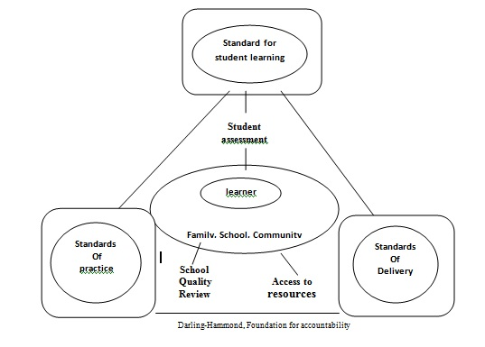
Study the diagram below which shows the learner and student assessment in the center of the Foundations for Accountability. Based in the diagram answer questions #143, 144 & 145.
143. What standards impinge directly on student assessment?
I. Practice
II. Student Learning
III Delivery
IV Family & Community

a. III & IV c. II & III
b. I & II d. I, II, III
144. How should the test results be used to advantage?
A. As index of comparing achievement
b. As indicator of learners’ knowledge of subject matter
c. As a means of assessing students’ performance in subject.
d. As indicator of learner’s performance with respect to competencies in the subject areas.

145. Which characterize the process approach of assessing student performance?
I. Teacher collects student work recorded in a portfolio
II. Teacher focuses on what students do while engaged in the learning process.
III. Students critically evaluate their own work
IV. Students select samples of what they think their learning
A. I and III
B. I, II, III, IV
C. II, IV, III
D. III and IV

146. When checking projects made by your pupils, what must be done to ensure objectivity in giving grades?

A. Prepare rubrics in giving grades
B. Request somebody to grade the projects of your classes
C. Rate the projects by batch checking
D. Rate the projects in descriptive and not in a quantitative manner

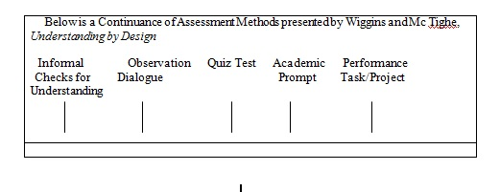

Based on the diagram’ answer questions #147 - #149
147. The assessment methods are considered to collect ________ of understanding overtime.

A. information
B. evidence
C. tasks
D. facts

148. When assessment is anchored on academic prompts the ongoing inquiry is _________ and ranges from simple to complex.
A. specific
B. generic
C. informal
D. open-ended

149. Assessment anchored on performance tasks on projects enables the students to use their knowledge in _______.
A. relationship
B. context
C. essentials
D. prioritization

150. Key question are considered in instruction planning and in identifying desired results and assessment. Which two questions are relevant?

I. What activities will equip students with the needed knowledge and skills?
II. What method of assessment should be used?
III. What materials and resources are best suited to accomplish the learning objective?
IV. Why type of tests should be given?
A. I and III
B. II and IV
C. II and III
D. IV only

4.4 Demonstrate skills in the use of techniques and tools in assessing affective learning

151. Which is one measure of attitude that consists of a value statement where you are asked to express your degree of agreement or disagreement of a statement?
A. Liked scale
B. Interview schedule
C. Semantic differential
D. Checklist

SITUATION – Here is one measure of attitude where a subject is asked to check the blank that corresponds to her answer.

Being Liked by Other Students
Important ____ ____ ____ Unimportant
Pleasant ____ _____ ____ Unpleasant

152. Question: How is it called?

A. Questionnaire checklist
B. Checklist
C. Likert scale
D. Semantic differential

153. Teacher F narrates: “I went through a test where I was asked how the ink blots appeared to me.” What test did Teacher F probably undergo?

A. IQ test
B. Rorschach test
C. Aptitude test
D. EQ test

154. Teacher U asked her pupils to create a story out of the given pictures. Which projective technique did Teacher U use?

A. Rorschach Test
B. Narrative
C. Thematic Apperception Test
D. Reflective

155. Which test will the Guidance Office of School give if it wants to help students in predicting their probable success in specific educational and vocational fields?

A. Diagnostic test
B. Achievement test
C. IQ test
D. Aptitude test

156. Which should you use to obtain information concerning a particular student’s interest?

I. Case study
II. Interview techniques
III. Cumulative record of student

A. III only
B. II and III
C. I and II
D. I, II, and III

157. Which tool should a teacher use if she wants to locate areas which are adversely affecting the performance of a significant number of students?

A. Problem checklist
B. Self- report technique
C. Autobiography
D. Cumulative Record

158. Student B was asked to report to the Guidance Office. Student B and his classmates at once remarked: “What’s wrong?”. What does this imply?

A. Reporting to a Guidance Office is often associated with misbehavior.
B. Student B is a “problem” student.
C. Guidance counselors are perceived to be “almighty and omniscient.”
D. The parents of Student B must be of the delinquent type.

159. Which is NOT true of the guidance process?

A. The guidance process means the guidance counselor decides what is best for the student who is in the dark.
B. The guidance process is a continuous process.
C. Guidance is meant for every student including the performing students.
D. Guidance is assisting students to become self-directed individuals.

160. With projective personality tests in mind, which does NOT belong?

A. Interview
B. Sentence completion task
C. Word Association test
D. Thematic Apperception Test

161. You intend to assess affective attributes such as capacity to feel, attitudes and behavior. Which of the following should you establish to certain the instrument’s validity?

A. Construct
B. Content
C. Criterion-related
D. Face

162. An appropriate assessment tool for assessing the development of learning in the affective domain is through __________________.

A. reading of journal entries
B. performance assessment
C. product assessment
D. self-assessment

163. Analytic scoring uses the _________ judgment of the student’s work.

A. evaluation
B. performance
C. standard
D. criterion

164. Knowledge of procedure in writing a report is an example of a _______ rubric.

A. specific
B. generic
C. standard
D. performance

165. Rubric are used for rating performance and scoring guides to describe the ________ qualities of student outcomes.

A. tested
B. accomplished
C. distinguished
D. desired

166. The Report Card is given every grading period to the pupil/student and the parents are informed of the learner’s performance. This is a/an _____ of the teacher stipulated in the Education Act. Of 1982.

A. role
B. obligation
C. accountability
D. desired

167. Teachers should avoid _______ in assigning student performance-based ratings.

A. arbitrariness and bias
B. unnecessary deductions
C. partially and calculation
D. unnecessary evaluation

168. Which is the basic principle underpinning the performance-based grading system?

A. It is tool for improving teaching and learning.
B. It is a tool to determine prerequisite knowledge.
C. It is diagnostic, formative and summative
D. It is evaluative and judgmental.

